**CSCI 2302**

**Exception Handling Chapter**

**Utilizing Java Predefined Class Lab**

Contents

Purpose 1

Learning Goals 1

Notes 1

Task 1

Input 3

Data 3

Output 3

Example of a run 3

Purpose: Work with exception handling.

Learning Goals: Exception Handling enables a program to deal with runtime errors and continue its normal executions. Exception handling enables a method to throw an exception to its caller.

Implement exception handling into creating objects that use user input to instantiate so that only valid objects will be instantiated.

Notes: Please see Exception Handling Notes.docx found on the Content Page.

Task:

1. Download ExceptionHandling_UsingLibraryLab.java, and save with mySFAUsername_ExceptionHandling_UsingLibraryLab.java.
2. In the main method, add the try..catch around the code that instantiates the NewLoans objects.
3. Modify the NewLoan class in the constructor to throw IllegalArgumentException if the loanAmount, annualInterestRate, or the numOfYears is less than or equal to zero, specifying which data type threw the exception.

(See the Exception Handling notes ExceptionHandlingNotes.java for some examples; can also be accomplished in the constructors or the setters.)



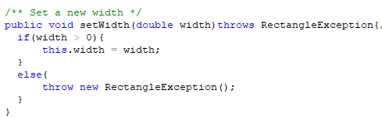

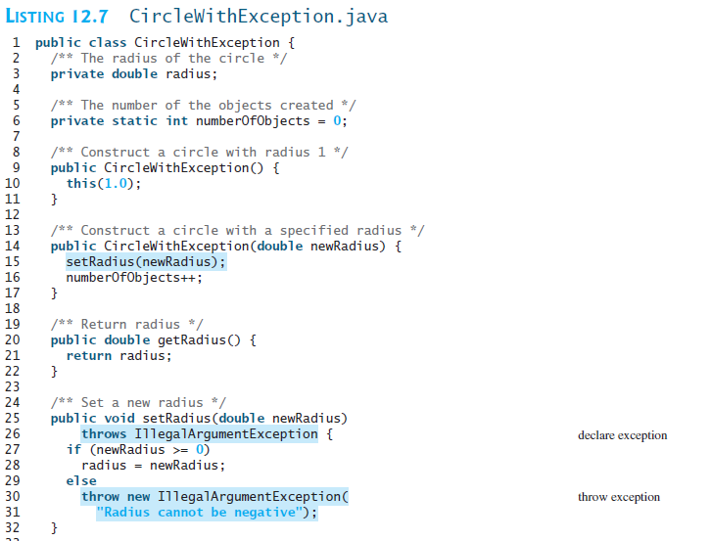

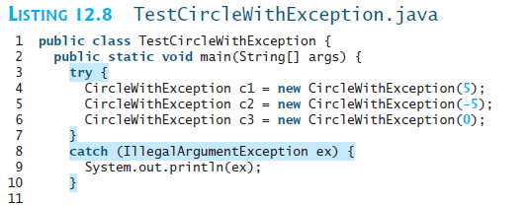

4. Run mySFAUsername_ExceptionHandling_UsingLibraryLab.java and make sure that you are understanding how this implementation is working.

Input: Read the input from a file, ehLabIn.txt (format: annualInterestRate, numOfYears, loanAmount).

Data: 3.6, 30, 100000

-1, 5, 25000

3.88, -3, 250000

8.91, 7, -20000

Output: Save the results to a file, ehLabOut.txt

Example of a run:

Creating loan: 3.6 APR, for 30 years, with a loan amount of $100000

Loan created!

Creating loan: -1 APR, for 5 years, with a loan amount of $25000

java.lang.IllegalArgumentException: Annual interest rate must be positive.

Creating loan: 3.88 APR, for -3 years, with a loan amount of $250000

java.lang.IllegalArgumentException: Number of years must be positive.

Creating loan: 8.91 APR, for 7 years, with a loan amount of $-20000

java.lang.IllegalArgumentException: Loan amount must be positive.

End of program